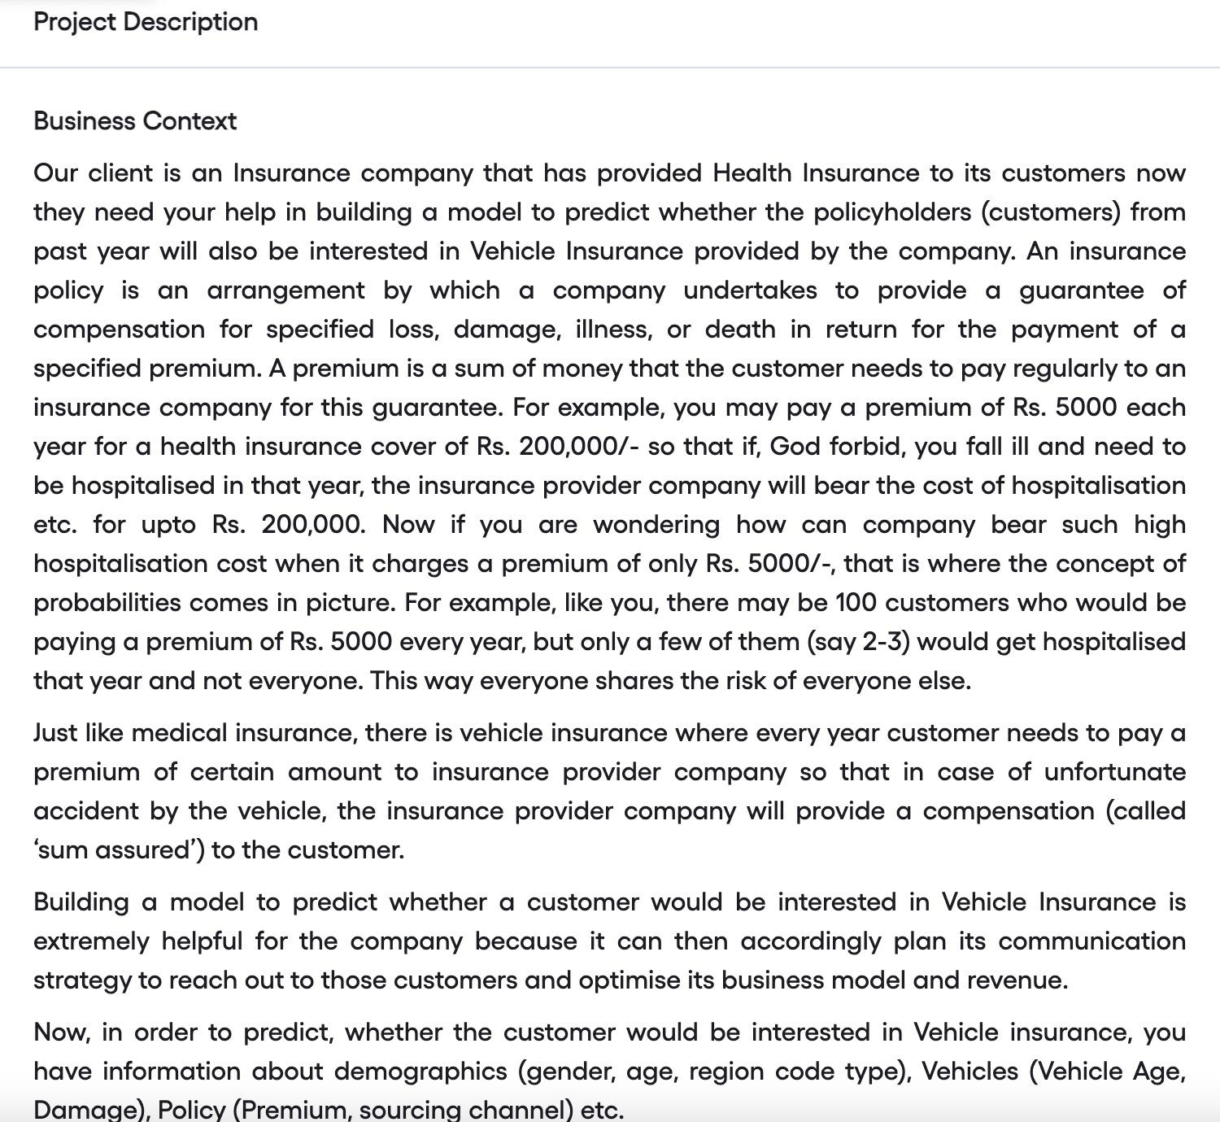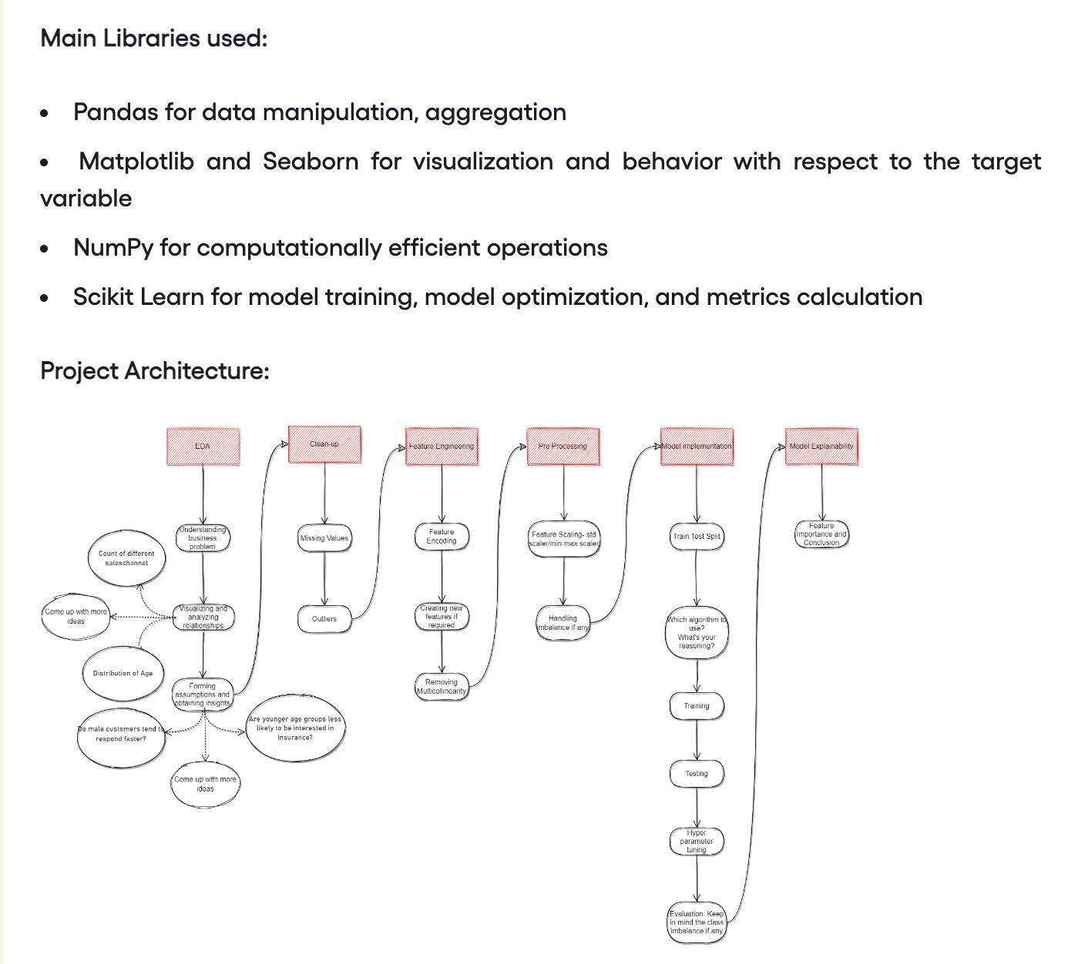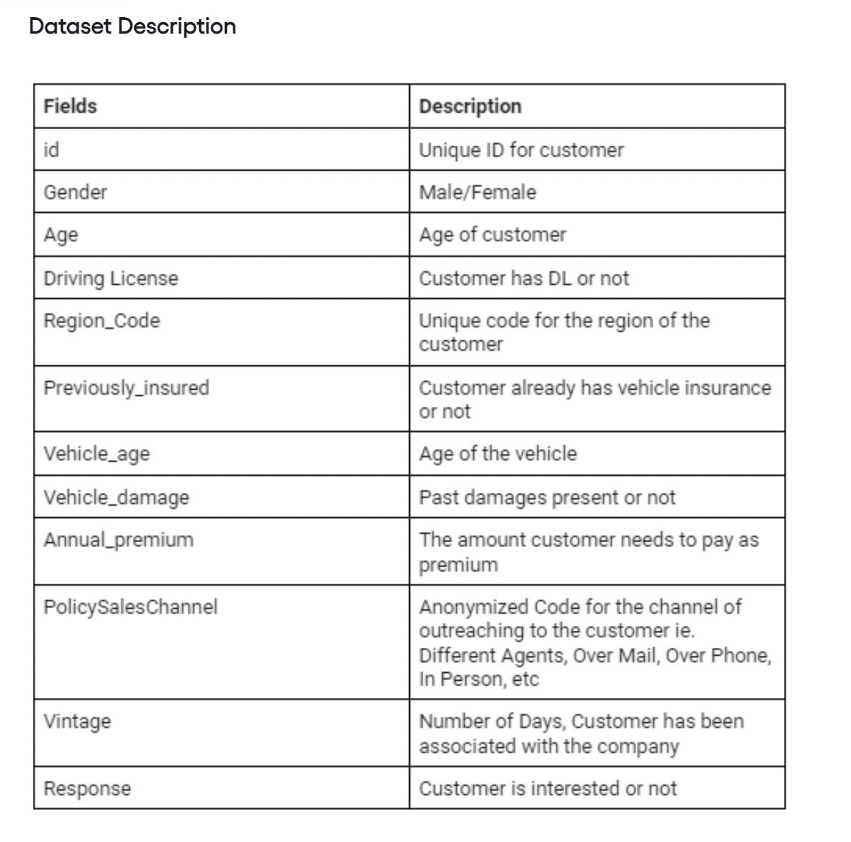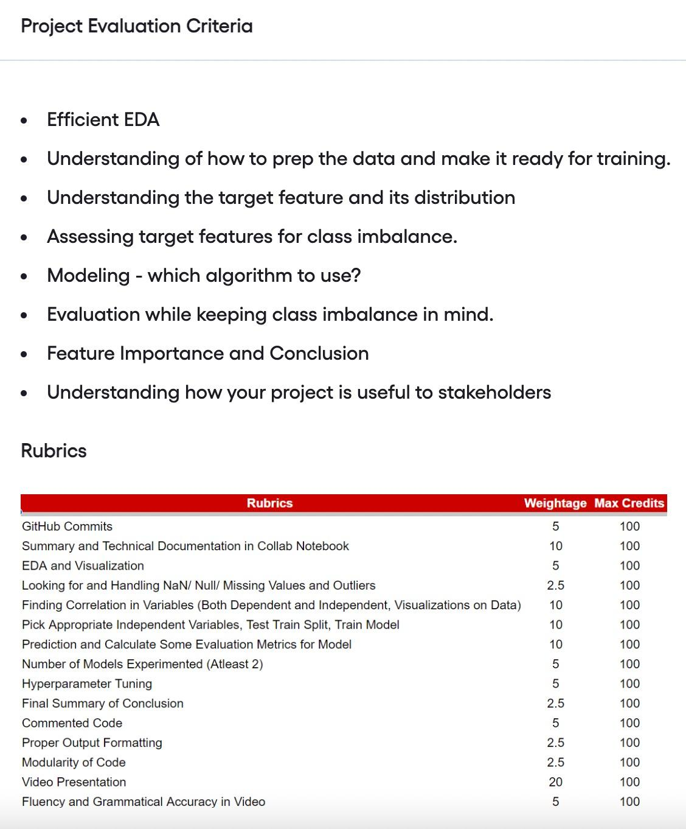  
  
[DataSet](https://drive.google.com/file/d/1E_1a8cuBAhp03N8lMEjwYAB7YqslKxhb/view?usp=sharing)